**Homework_4**

杜闻峥 SA22008303

1. Utilizing openstreesmap plugin in QGIS to find and download the map of the Doubs river (map: https://www.openstreetmap.org/relation/156145#map=9/47.1085/6.1057&layers=H), and download the map as a geojson format, which is becoming popular for encoding a variety of geographic data structures.

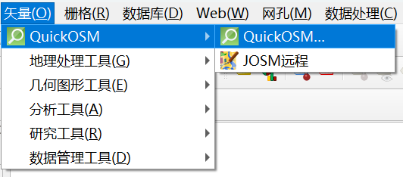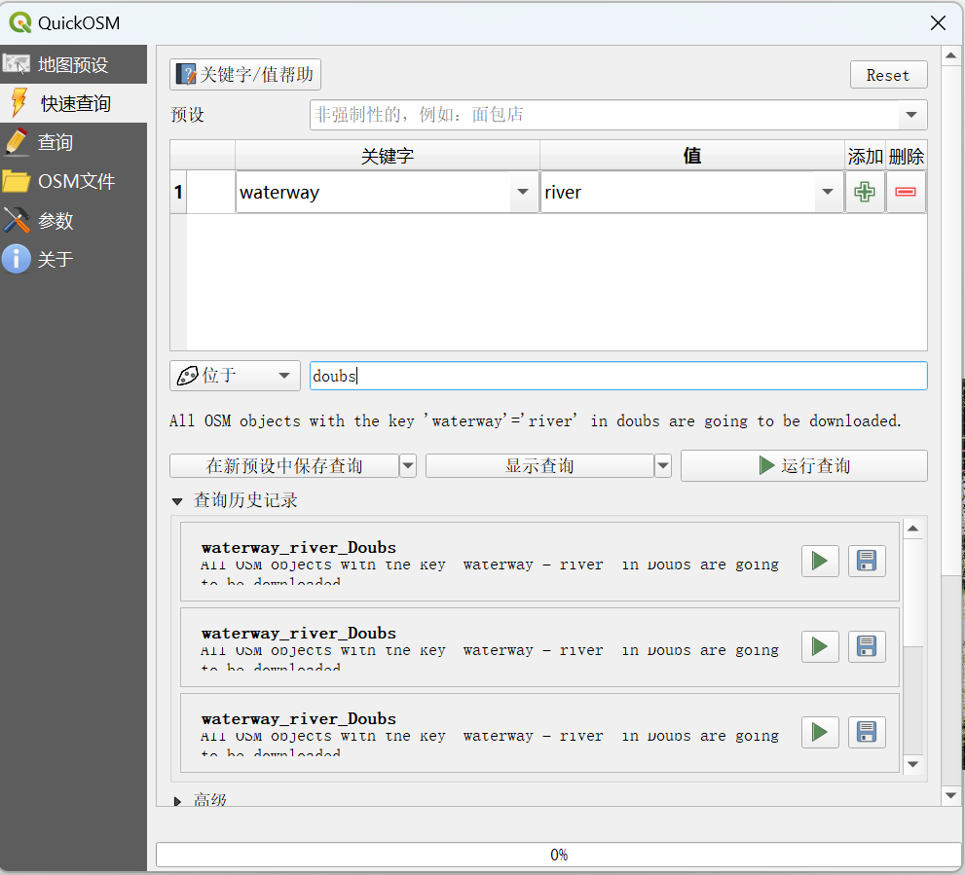

下载为geojson格式保存

2. You’d better to check the structure of the regions object by plotting the simple feature collection and dissolve the internal boundaries of the region if the geojson file contains. After that, please set the area that the river undergoes as the area of interest (AOI).

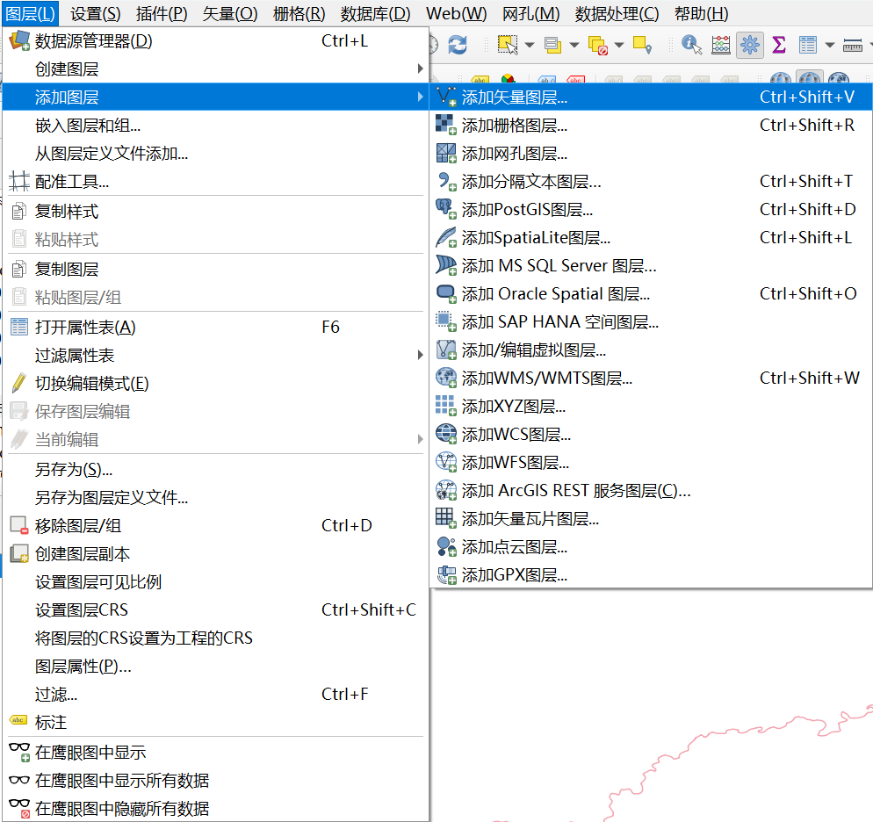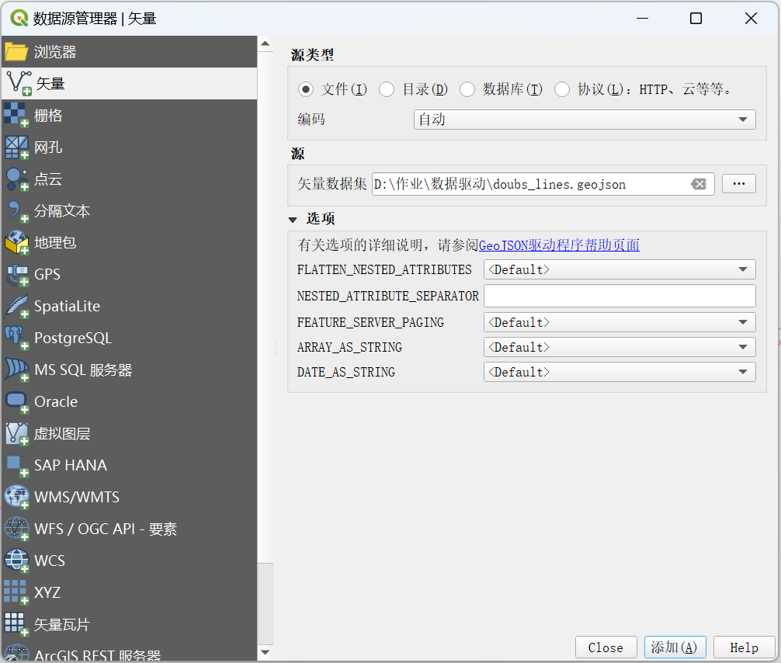

添加doubs河流矢量为图层，检查特征后选出AOI

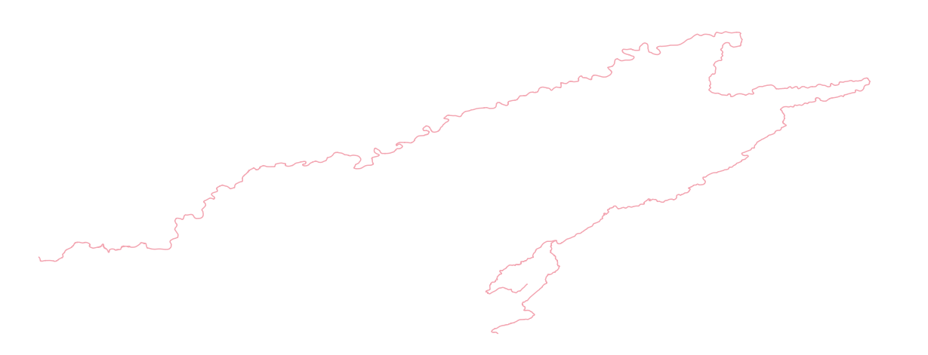

3. Create an account of one of these geospatial official websites, such as USGS, EARTHDATA, Copernicus data space, and login in for check the images that the river covers. Filtering the records to keep only Landsat images with LandCloudCover lower than 10%, and try to find what products levels. Please note whether the records contain sr_ndvi. The normalized difference vegetation index, NDVI, provides a rough estimate of the abundance of healthy vegetation and provides a means of monitoring changes in vegetation over time. You can download through manual methods directly from the geospatial websites or by other means, including QGIS and R package.

登陆copernicus网站并注册，搜索doubs

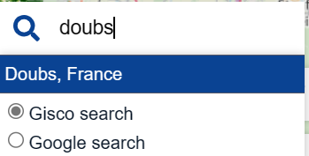

修改LandCloudCover最大值为10%

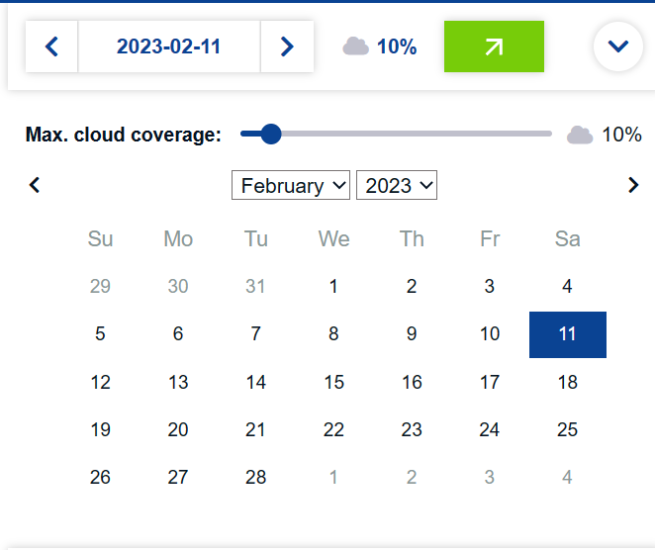

查看doubs矢量的图层CRS，为EPSG：4326-WGS 84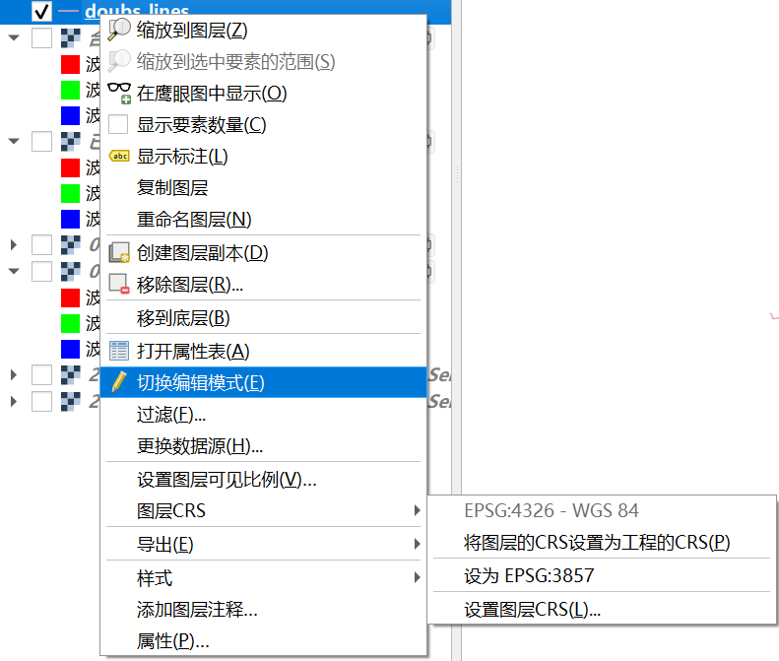

在copernicus选择能大致覆盖整个doubs流域的两张图片，选择NDVI并下载两张图片，选择格式为TIFF，图层为NDVI，并选择doubs一致的CRS

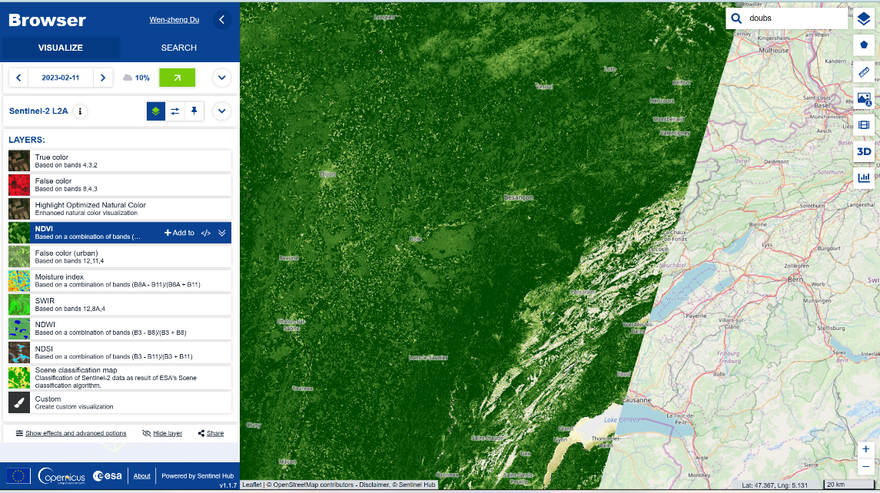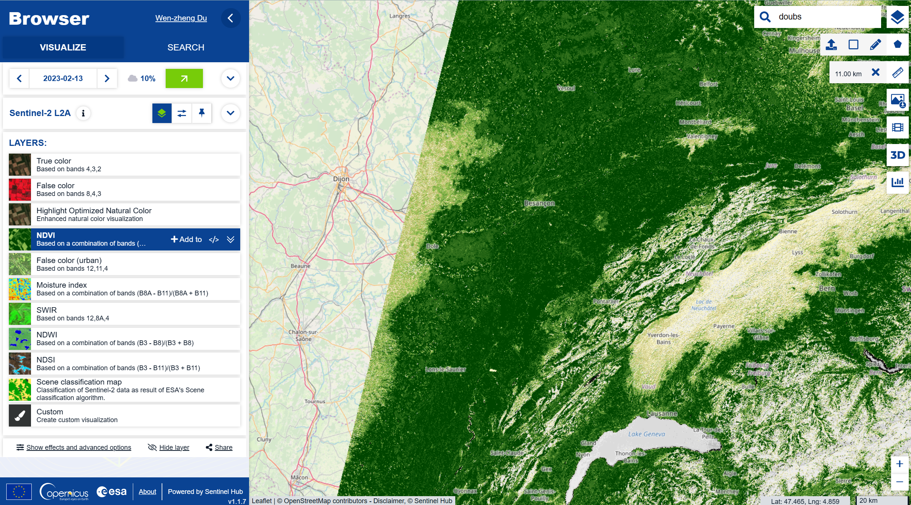

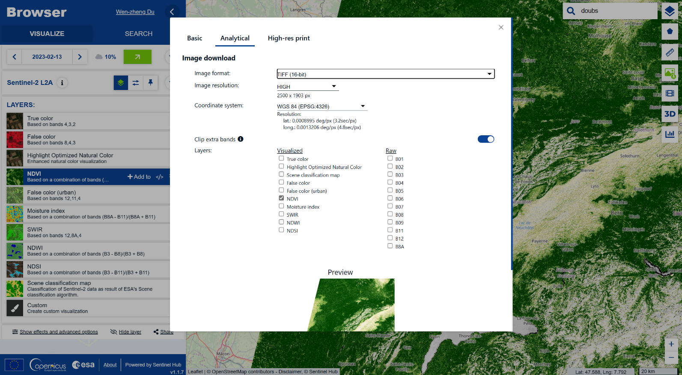

4. Load the NDVI raster file and check whether its crs is identical to AOI. If not, transform the crs of AOI vector into the another which is the same as that of NDVI. After that, you can crop and mask the NDVI for a small area, which just covers the AOI. Plot the cropped NDVI.

将获得的两张栅格图片添加到图层中

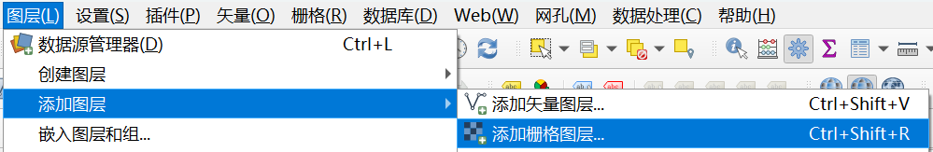

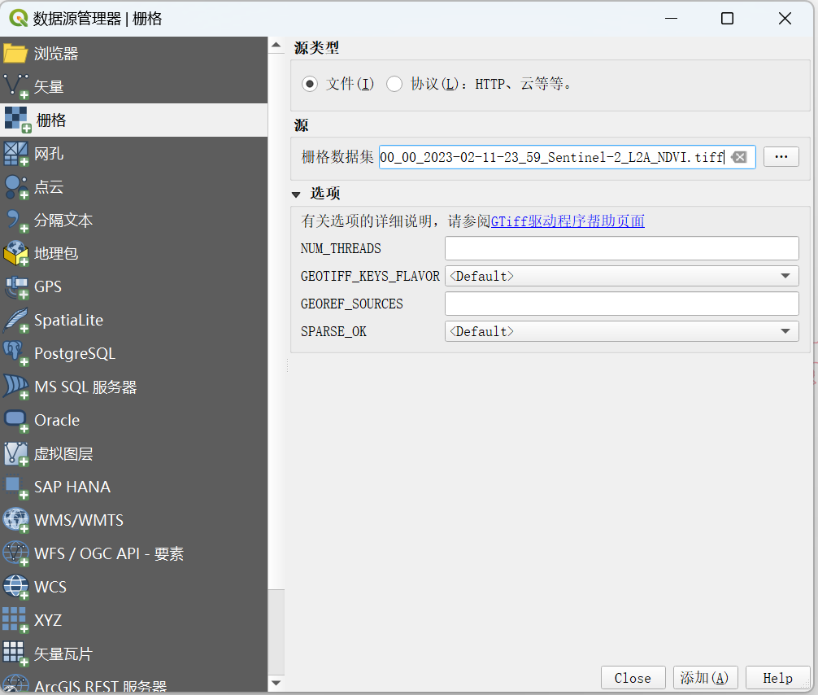

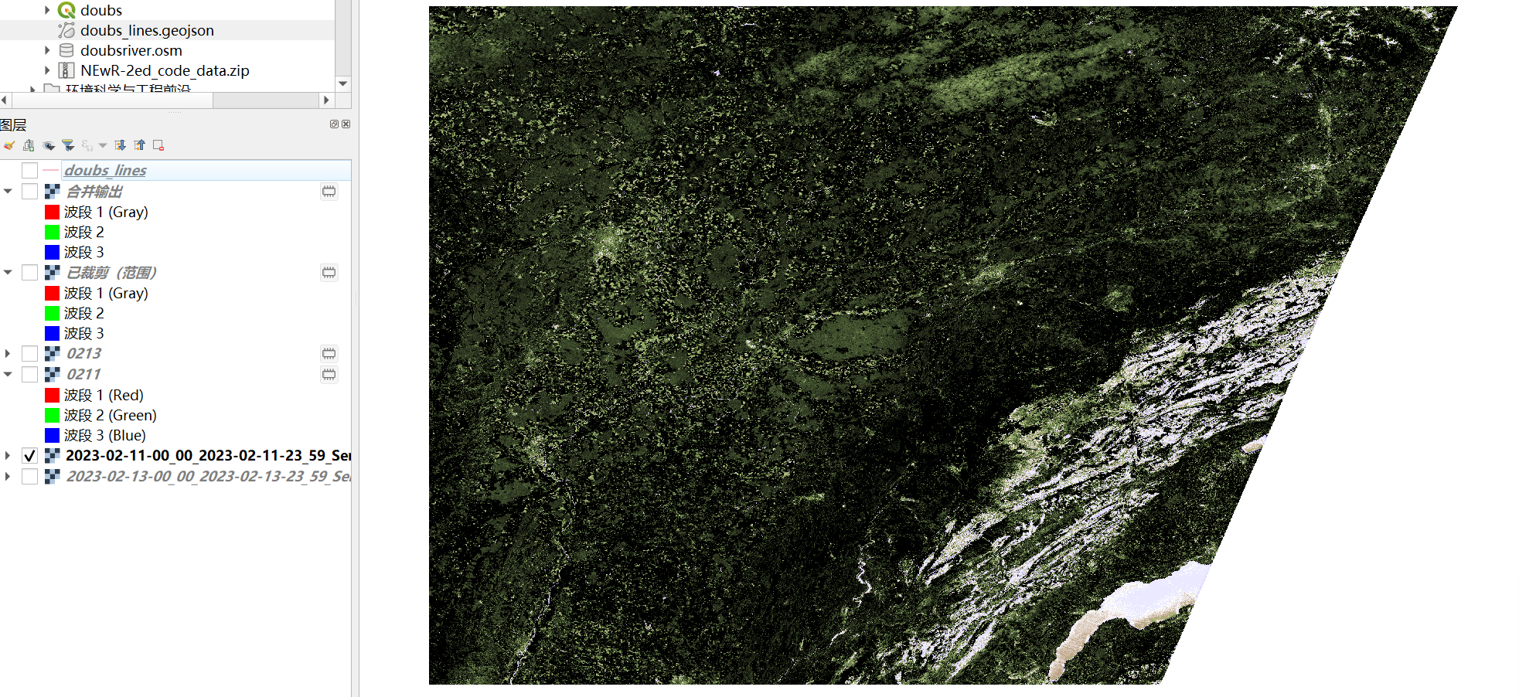

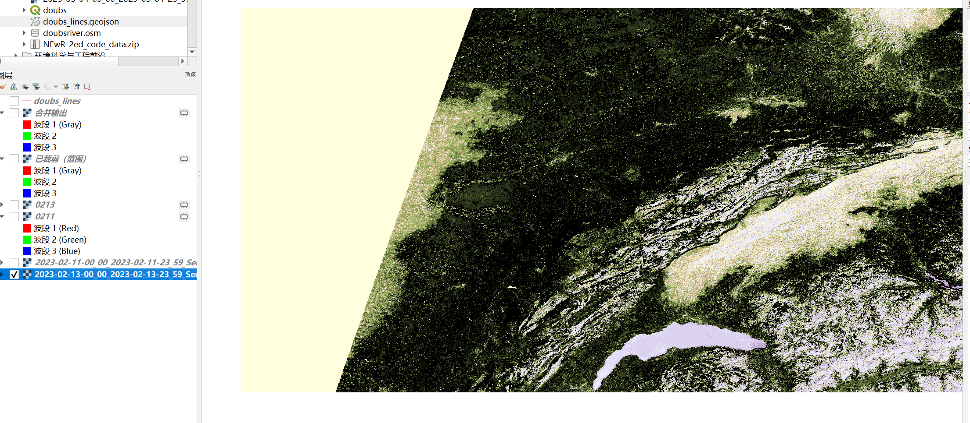

将两个图片合并

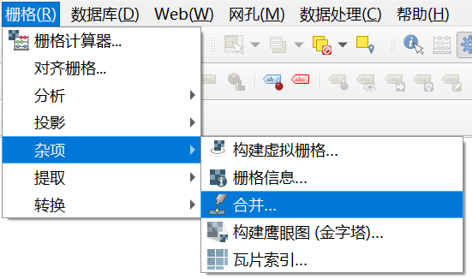

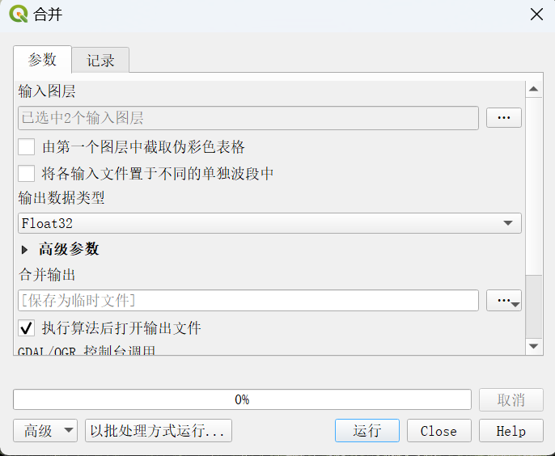

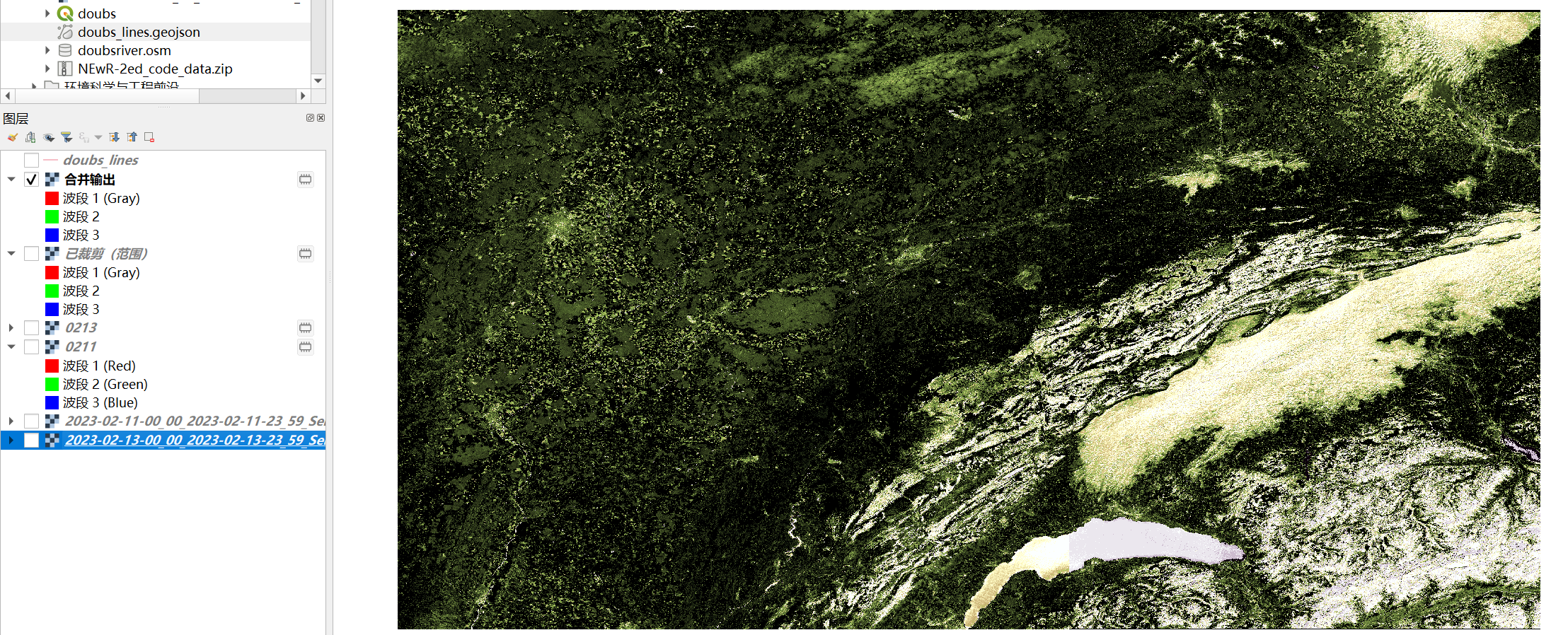

将合并后的栅格按照doubs流域裁剪

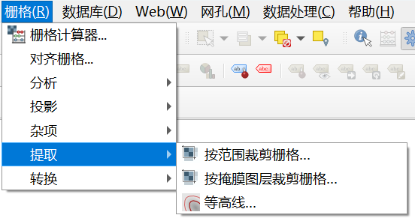

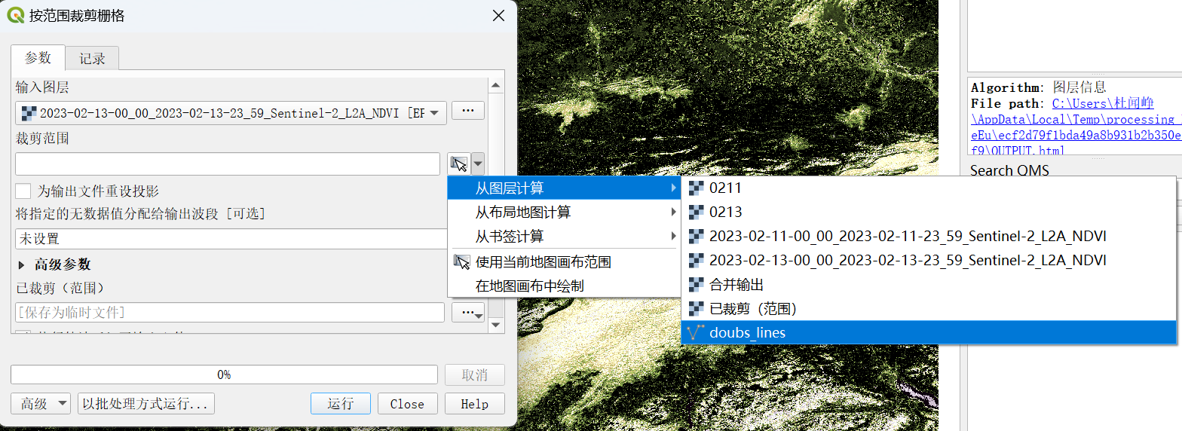

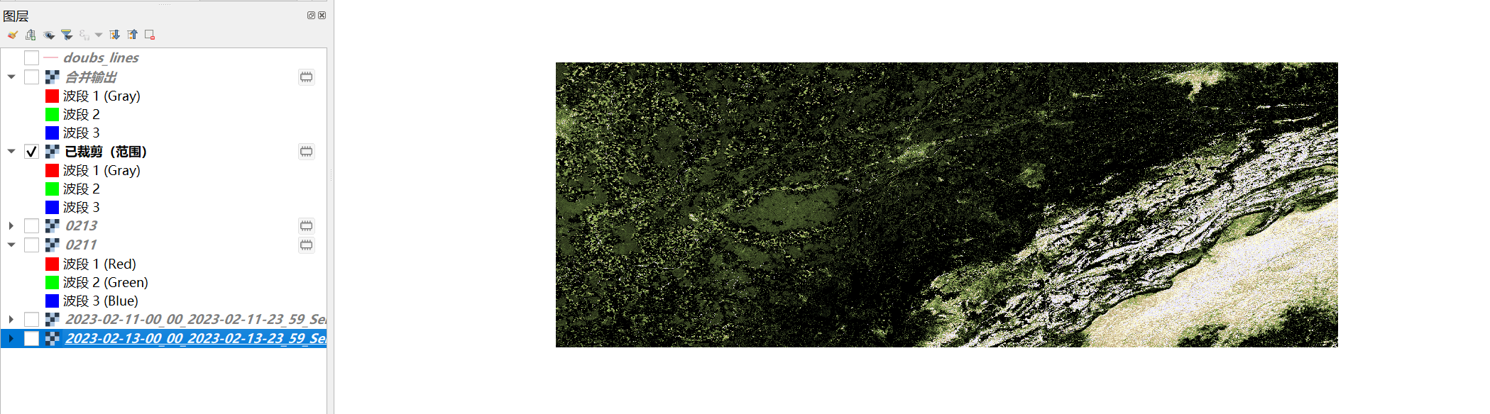

获得最终结果

